#### [6wut](https://www.rcsb.org/structure/6WUT) (3.00Å) Mitochondrial SAM complex

#### ([Omp85 domain-containing protein](https://www.rcsb.org/groups/sequence/polymer_entity/G2QFF9)) location 47-512 (466aa)

**Align Executive: RMSD =**0.349 (2957 to 2957 atoms)

**Align Native_6wut and ss H, QTY_6wut and ss H, cycles=0,**

**Executive: RMSD** = 0.456 (62 to 62 atoms)

Superimposed Native and QTY varient

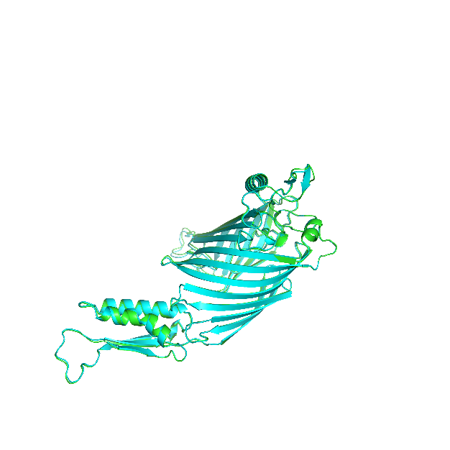 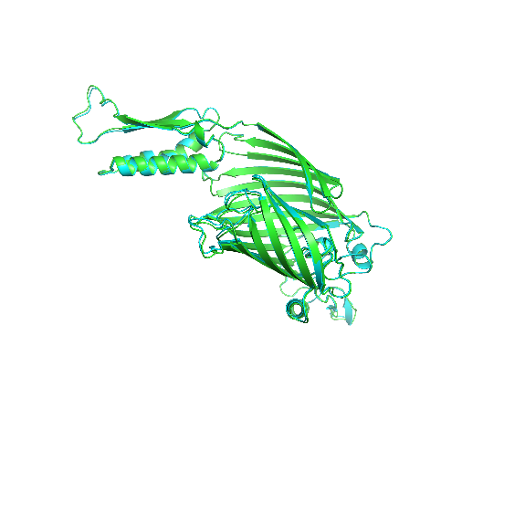

X-180 Rotation

X-90 Rotation

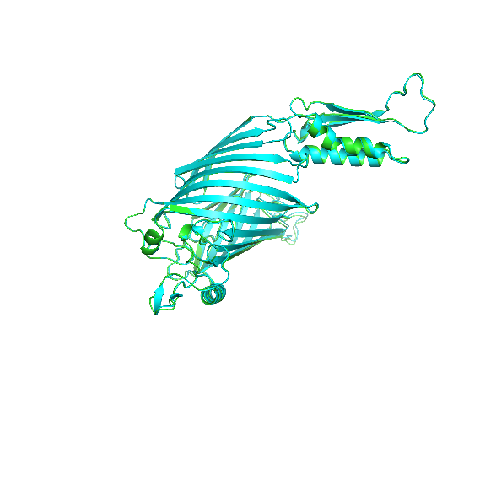

Y-180 Rotation

**ChimeraX 1.4 software for hydrophobic nature of 6WUT Mitochondrial beta-barrel outer membrane protein**

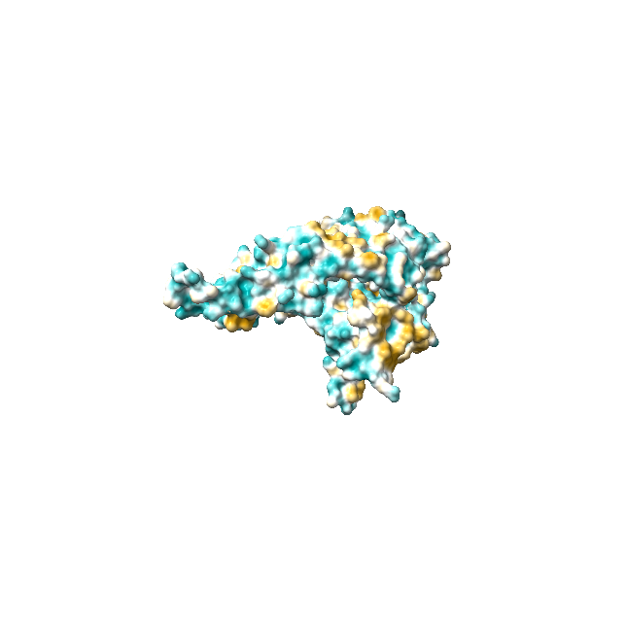 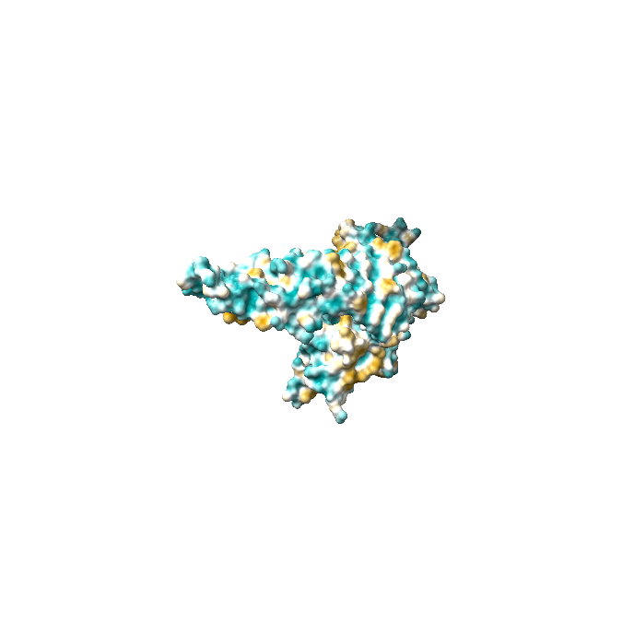

1. Native 6wut (b) QTY variant 6wut**QTY**

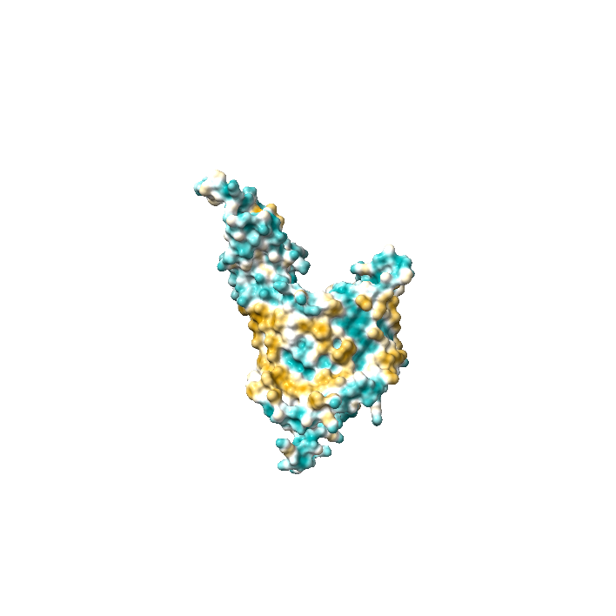 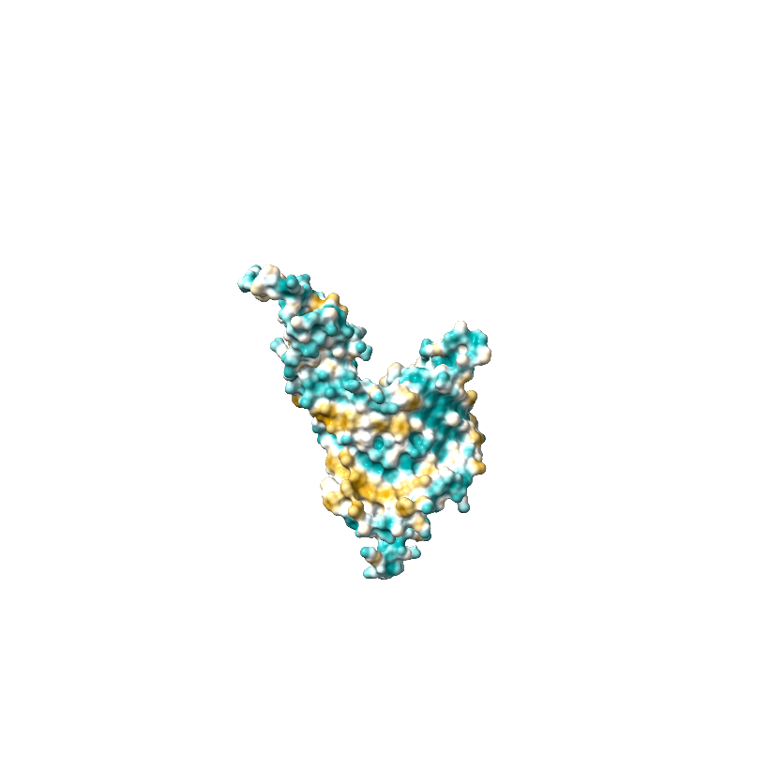

1. Native 6wut (d) QTY variant 6wut**QTY**

Fig1: Mitochondrial SAM complex 6wut Amino acids from 47 to 512 ,Omp85 domain-containing protein (Mitochondrial membrane protein)

Akash S S, BSMS chemistry, Indian institute of science education and research, Tirupati.

Kathryn A Diederichs, Xiaodan Ni, Sarah E Rollauer, Istvan Botos, Xiaofeng Tan, Martin S King, Edmund R S Kunji, Jiansen Jiang, Susan K Buchanan.

[Structural insight into mitochondrial β-barrel outer membrane protein biogenesis](https://pubmed.ncbi.nlm.nih.gov/32620929/).